**NETAJI SUBHAS UNIVERSITY OF TECHNOLOGY**

**B.TECH. PROJECT ON**

# **Study on**

**Free Space Optical Communication**

**Lakshay 2020UEI2801**

**Deepanshu 2020UEI2810**

**Deepanshu Mehandia 2020UEI2812**

**Bhishek Ranga 2020UEI2849**

Under the Guidance of

## **Dr. Sanya Anees**

**Project-II in** **partial fulfillment of requirement for the award of B.Tech. in Electronics & Communication Engineering**

***with specialization in***

***Internet of Things***



**Division of Electronics & Communication Engineering**

**NETAJI SUBHAS UNIVERSITY OF TECHNOLOGY**

**NEW DELHI-110078**

**06 MAY 2024**

# **CERTIFICATE**

Certified that Name of students (**2020UEI2801, 2020UEI2810, 2020UEI2812, 2020UEI2849**) has carried out their project work presented in this project entitled **“Study on Free Space Optical Communication”** for the award of Bachelor of Technology, Department of Electronics and Communication, Netaji Subhas University of Technology, New Delhi, under my supervision. The project embodies results of original work, and studies are carried out by the student himself and the contents of the project do not form the basis for the award of any other degree to the candidate or to anybody else from this or any other University/Institution.

**Dr. Sanya Anees**

**(Assistant Professor)**

Date: 06 MAY 2024

# **ACKNOWLEDGEMENT**

We would like to express my gratitude and appreciation to all those who make it possible to complete this project. Special thanks to our project supervisor **Dr. Sanya Anees** whose help, stimulating suggestions and encouragement helped us in writing this report. We also sincerely thank our colleagues for the time spent proofreading and correcting our mistakes.

**Lakshay**

**Deepanshu**

**Deepanshu Mehandia**

**Bhishek Ranga**

# **PLAGIARISM REPORT**

# **ABSTRACT**

Optical wireless communication (OWC) refers to transmission in unguided propagation media using optical carriers, i.e., visible, infrared (IR), and ultraviolet (UV) bands. In this survey, we focus on outdoor terrestrial OWC links which operate in near IR band. These are widely referred to as free space optical (FSO) communication in the literature. FSO systems are used for high-rate communication between two fixed points over distances up to several kilometers.

In comparison to radiofrequency (RF) counterparts, FSO links have an extremely high optical bandwidth available, allowing much higher data rates. They are appealing for a wide range of applications such as metropolitan area network (MAN) extension, local area network (LAN)-to-LAN connectivity, fiber back-up, backhaul for wireless cellular networks, disaster recovery, high-definition TV and medical image/video transmission, wireless video surveillance/ monitoring, and quantum key distribution, among others.

Despite the major advantages of FSO technology and variety of its application areas, its widespread use has been hampered by its rather disappointing link reliability particularly in long ranges due to atmospheric turbulence-induced fading and sensitivity to weather conditions. In the last five years or so, there has been a surge of interest in FSO research to address these major technical challenges. Several innovative physical layer concepts, originally introduced in the context of RF systems, such as multiple input multiple-output communication, cooperative diversity, and adaptive transmission have been recently explored for the design of next generation FSO systems. In this paper, we present an up-to-date survey on FSO communication systems.

The first part describes FSO channel models and transmitter/receiver structures. In the second part, we provide details on information theoretical limits of FSO channels and algorithmic-level system design research activities to approach these limits. Specific topics include advances in modulation, channel coding, spatial/cooperative diversity techniques, adaptive transmission, and hybrid RF/FSO systems.

**CONTENTS**

|  |  |
| --- | --- |
| **Title** | **Page No.** |
| **Certificate** | **2** |
| **Acknowledgement** | **3** |
| **Plagiarism Report** | **4** |
| **Abstract** | **5** |
| **List of figures** | **7** |
| **Introduction** | **8** |
| **System Model** | **10** |
| **Channel Modelling** | **14** |
| **Result** | **20** |
| **Conclusion** | **26** |
| **Conference Paper** | **27** |
| **Proof of Submission** | **35** |
| **References** | **38** |

**LIST OF FIGURES AND TABLES**

|  |  |
| --- | --- |
| **Figure** | **Page No.** |
| **Fig.1 System Model** | **10** |
| **Fig. 2 Terrestrial Model** | **11** |
| **Fig. 3 Aerial Model** | **12** |
| **Fig. 4 Schematic of optical uplink** | **13** |
| **Fig. 5 Outage Probability vs. SNR** | **21** |
| **Fig. 6 Average BER vs. SNR** | **22** |
| **Fig. 7 Average BER vs. SNR** | **23** |
| **Fig. 8 Average BER vs. SNR** | **24** |
|  |  |
| **Table** | **Page No.** |
| **Table 1. Parameters (*x* and *y*) for various binary modulation technique** | **19** |

**INTRODUCTION**

Free space optical (FSO) communication systems offer numerous advantages, including low power requirements, cost-effective installation and operation, license-free spectrum usage, immunity to interference, and high bandwidth capacity (up to 10 Gbps). These characteristics make FSO systems attractive for various terrestrial and satellite communication applications, such as last mile access, backhauling services, data recovery, and high-definition transmission.

However, the performance of FSO systems is heavily influenced by atmospheric conditions, path loss, and pointing errors. Vibrations in transmitted laser beams, caused by factors like wind, earthquakes, and thermal expansion of tall buildings, often lead to misalignment between the transmitter and receiver, resulting in pointing errors.

The increasing demand for high-speed and reliable communication has spurred the exploration of innovative technologies, with one promising avenue being the integration of FSO with radio frequency (RF) communication. The decode-and-forward dual-hop asymmetric FSO communication system represents a significant advancement, combining the robustness of RF with the high bandwidth capabilities of FSO.

This system involves relaying information through an intermediary node using the decode-and-forward protocol. Evaluating the performance of this dual-hop asymmetric system is crucial for understanding its behavior under different conditions. The asymmetry in the FSO and RF links introduces complexities related to fading, turbulence, path loss, and pointing errors. Performance assessment involves analyzing key metrics such as outage probability, bit error rate (BER), and channel capacity.

Researchers aim to unravel the intricate interplay of FSO components, providing insights into the system's reliability, robustness, and overall efficiency. This research contributes to the evolving landscape of FSO communication systems by conducting a detailed performance evaluation of the decode-and-forward dual-hop asymmetric configuration.

Through analytical modeling and simulations, the study seeks to derive mathematical expressions and finite power series-based formulations for outage probability, BER, and channel capacity. Factors considered include atmospheric turbulence, path loss, and pointing errors, creating a comprehensive assessment framework.

One significant advantage of the decode-and-forward protocol in this context is its ability to mitigate the impact of fading and signal attenuation. In a dual-hop configuration, the intermediary node acts as a buffer, intercepting and decoding the FSO signal before retransmitting it via RF. This process allows for error correction and signal regeneration, improving overall system performance and reducing the probability of data loss.

However, challenges remain in optimizing the performance of such hybrid systems, particularly in addressing the complexities introduced by atmospheric turbulence and pointing errors. These factors can degrade signal quality and introduce variability in transmission characteristics, impacting the overall reliability and efficiency of the communication link.

To address these challenges, ongoing research focuses on refining modeling techniques and developing adaptive algorithms to dynamically adjust transmission parameters in response to changing environmental conditions. By incorporating real-time feedback mechanisms and predictive analytics, future iterations of dual-hop asymmetric FSO systems aim to further enhance performance and resilience in diverse operating environments.

In summary, this performance evaluation aims to illuminate the strengths and limitations of the decode-and-forward dual-hop asymmetric FSO communication system. The outcomes of this study can guide the optimization of such systems, leading to advancements in hybrid communication technologies and their application in diverse scenarios.

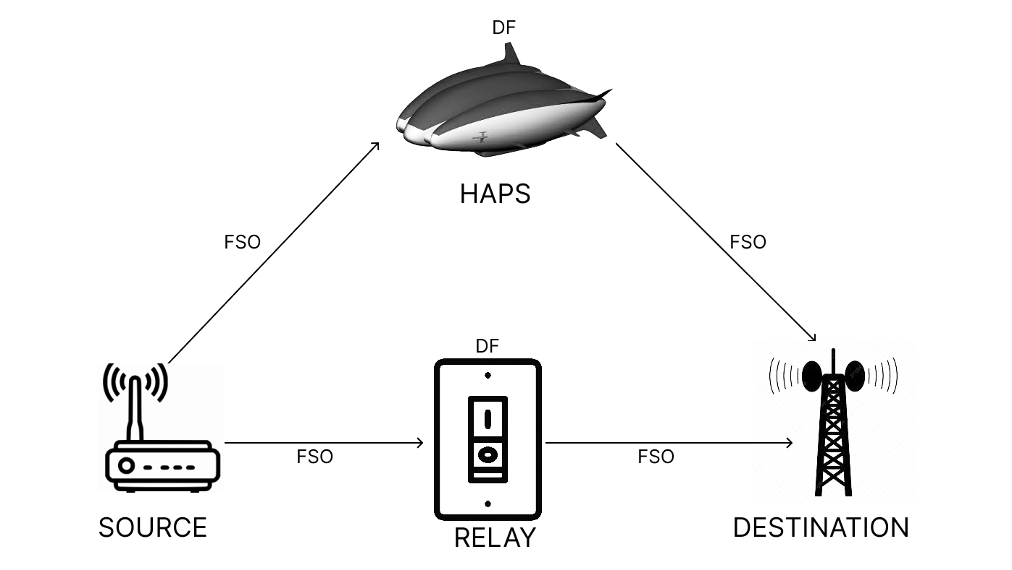**SYSTEM MODEL**

**Fig. 1** System model

Consider an asymmetric dual-hop cooperative communication system divided into two parts; one is a terrestrial communication system, and the other is an aerial communication system. In the terrestrial communication system, a source (S) communicates with a destination (D) via a relay node (R), as shown in figure. A scenario of FSO wireless communication is assumed that is, the S-R link and the R-D link, both of which are FSO links characterized by path loss, Gamma-Gamma distributed turbulence, and pointing errors. In the Fig. 2, γs,r and γs,d are the instantaneous signal-to-noise ratios (SNRs) of the S-R and the R-D links, respectively, σ2s,r and σ2r,d are the AWGN variances of the S-R and the R-D links; a and b are the atmospheric turbulence parameters that depend upon the FSO link length, L, operating wavelength, and the refractive-index structure parameter,

**Cn2, as a = [exp(0.49 σl2/(1 + 1.11 σ12/5)7/6) - 1]-1 and b = [exp(0.51 σl2/(1 + 0.69 σ12/5)5/6) - 1]-1**

where the Rytov variance of σ2l = 1.23 Cn2k7/6 L11/6, in which wave number k=2π/λ. The relay contains hybrid capabilities; it decodes the data transmitted by S and transmits the newly encoded data over the FSO link to D, by using a SIM scheme.

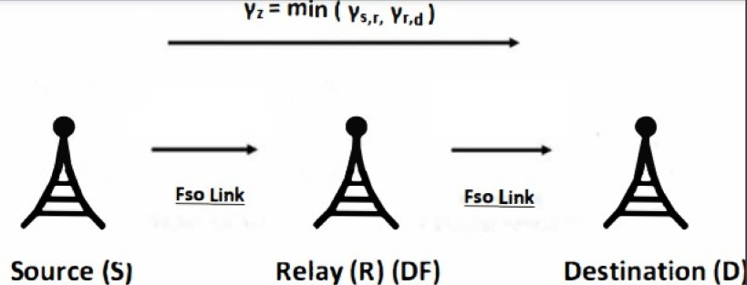**Fig. 2** Terrestrial Model

Now, in the aerial communication system, a source (S) communicates with a destination (D) via a HAPS node (H), as shown in Fig. A scenario of FSO wireless communication is assumed, that is, the S-H link and the H-D link, both of which are FSO links characterized by path loss, Gamma—Gamma distributed turbulence, and pointing errors. In Fig. 1, γs,h and γh,d are the instantaneous signal-to-noise ratios (SNRs) of the S-R and the R-D links, respectively, σ2s,h and σ2h,d are the AWGN variances of the S-H and the H-D links; a and b are the atmospheric turbulence parameters, which depend upon the FSO link length, L, operating wavelength, and the refractive-index structure parameter,

**Cn2, as a = [exp(0.49 σl2/(1 + 1.11 σ12/5)7/6) - 1]-1 and b = [exp(0.51 σl2/(1 + 0.69 σ12/5)5/6) - 1]-1**

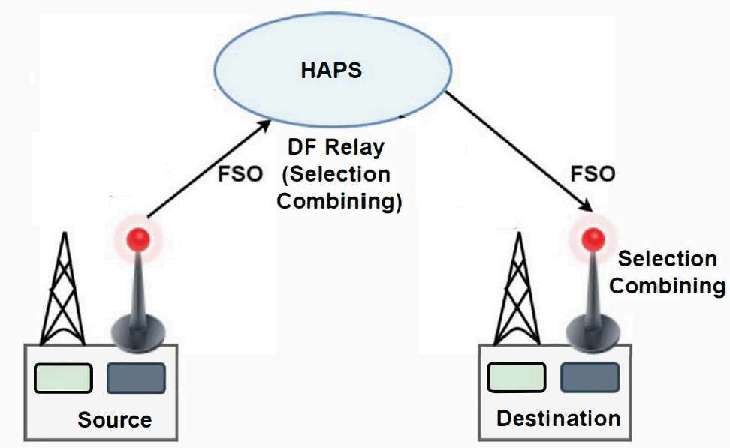where the Rytov variance of σ2l = 1.23 Cn2k7/6 L11/6, in which wave number k=2π/λ. HAPS works as a relay in DF mode between Source and Destination nodes. The FSO systems incorporate the SC technique, which selects the signal with the best SNR at both HAPS and Destination. As HAPS works in DF mode, the signal with higher SNR in the Source-HAPS link is first decoded, then re-encoded and forwarded to the Destination using the FSO system. Like, HAPS node, Destination selects the signal with a higher SNR in the HAPS-Destination link and decodes the signal.

**Fig. 3** Aerial Model

The FSO link is characterized by atmospheric attenuation, Gamma-Gamma distributed turbulence, Rayleigh distributed pointing errors, and the impacts of hovering fluctuations of the considered HAPS. It is worth mentioning that the position vibrations of the optical receiver as well as the AOA fluctuations of the received optical beam are lumped together in hovering fluctuations.

The received signal at HAPS transmitted by Source via the FSO link is given by,

**YH,f = η1g1 xS + eH,**

where pi is the photo-electronic conversion ratio of the considered photodetector (PD) at HAPS, g1 is the FSO channel coefficient, and eH is the complex-valued AWGN with zero mean and variance σ2 e, H. The instantaneous and average optical-equivalent electrical SNRs of the source-HAPS FSO link can be represented as,

**γfso1 = η12 Pt1 |g1|2 /(σe,H2) and µfso1 = η12 Pt1 E |g1|2 /(σe,H2),**

respectively, where Pt1 denotes the equivalent transmit power of the SGS node for FSO node transmission.

The signal received at the destination through the HAPS-D FSO link is given by yD,f = η2 g2 xs + eD, where, η2 is the photo-electronic conversion ratio of the considered PD at DGS, g2 is the FSO channel coefficient, and eD is the AWGN with zero mean and variance σ2 e,D. The instantaneous and average optical-equivalent electrical SNRs of the (HAPS-DGS) FSO link are,

**µfso2 = η22 Pt2 E |g2|2 /(σe,D2), and γfso2 = η22 Pt2 |g2|2 /(σe,D2)**

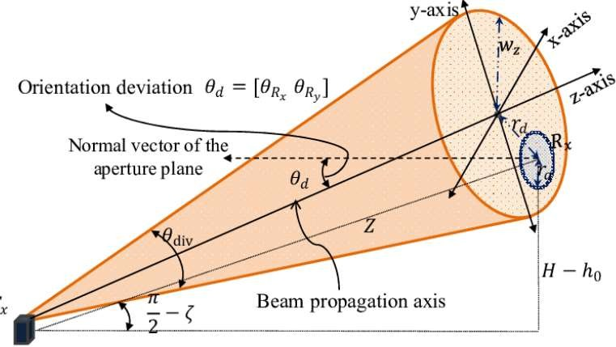where, Pt2 represents the electrical equivalent transmit power of HAPS for the FSO mode of data transmission. Finally, at destination, SC is performed and detects the signal transmitted from the HAPS.

Now, let's assume that the instantaneous signal-to-noise ratio from source to relay is said to be γ1, γ2 from relay to destination.

**Fig. 4** Schematic of optical uplink

Furthermore, the whole SNR for the terrestrial system will be γt and γa for the aerial system.

**γt = min ( γ1 , γ2 ) and γa = min ( γ3, γ4 )**

**CHANNEL MODELING**

The mathematical expressions of CDF and PDF of the DF-based dual-hop asymmetric FSO systems are derived for the following two scenarios, considering only turbulence in the FSO link in the first scenario and the combined effect of turbulence, path loss, and pointing error in the FSO link in the second scenario.

**UNDER ATMOSPHERIC TURBULENCE** The FSO link experiences Gamma-Gamma distributed turbulence; the statistical characteristics are obtained as follows:

If the FSO link is assumed to undergo Gamma-Gamma turbulence only, then the PDF of γr,d is given by,

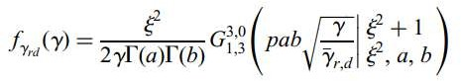

where y = Yrd/h,Aop, p= 2/(2+1), Ao = [erf(vp.g)]2, v= √z/2R/Wb = w/(20), erf() denotes the error function, R is the radius of the receiver aperture, we is the normalized beam waist, we is the equivalent beam waist and σs is the pointing error displacement standard deviation at the receiver. Similarly, PDF of γs,r can also be given like this.

Using this, the CDF of yr,d can be derived as,

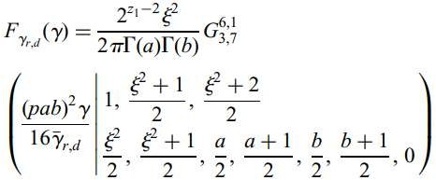

Where, z1 = a + b, z2 = a - b and G(.) is the Meijer-G function.

The PDF of γ3 can be derived as,

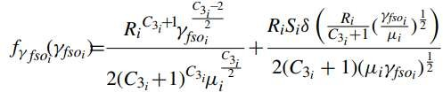

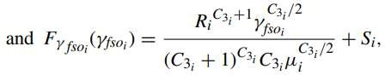

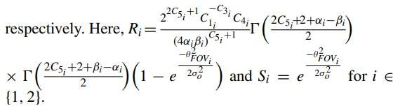

**Statistical characteristics of dual hop DF based FSO system**

The mathematical expressions of CDF, PDF of the DF based dual-hop asymmetric FSO-FSO systems are derived for the following two scenarios, considering only turbulence in the FSO link in the first scenario and combined effect of turbulence, path loss and pointing error in the FSO link in the second scenario.

**Under atmospheric turbulence**

When the FSO link experiences Gamma-Gamma distributed turbulence, the statistical characteristics are obtained as follows.

**Cumulative distribution function**

Using **γ**z = min (γs,r , γr,d ) we can say that the CDF of the equivalent SNR (γz) for the considered FSO system is given by,

**Fγz (γ) = Fγs,r (γ) + Fγr,d (γ) - Fγs,r (γ)Fγr,d (γ)**

where **Fγs,r** is the CDF of the instantaneous SNR of the S-R link. Using the relation,

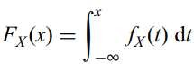

And the CDF of **γ**z can be written as,



where **γ**(s, x) = x 0 t s-1 e -t dt represents the lower incomplete Gamma function, K1 = 1/G(m), K2 = (1/G(a)G(b)) ab/gr,d and W1 = ab/gr,d.

**Probability density function (PDF)**

The PDF of the equivalent SNR for the DF based dual hop system is given by,



the PDF can be obtained as,

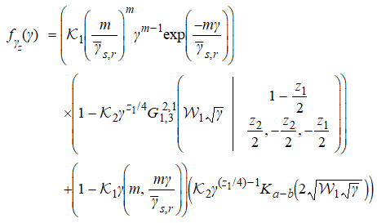

**Under the combined effect of path loss, atmospheric turbulence and pointing error**

When the FSO link is characterized by the path loss, Gamma-Gamma distributed turbulence and pointing error, the statistical characteristics are obtained as follows,



where K4= 2z1—2 j 2 /(2pG(a)G(b)), W4 = (pab) 2 /(16gr,d), P3 = (j 2 + 1)/2, (j 2 + 2)/2 and P4 = j 2 /2, (j 2 + 1)/2, a/2, (a + 1)/2, b/2, (b + 1)/2.

The pdf can be obtained by,

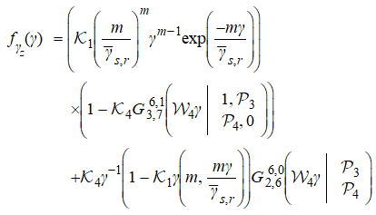

**Performance of the dual-hop asymmetric FSO cooperative system**

**Outage probability:** Outage probability is defined as the probability at which the equivalent SNR, γz, falls below a predetermined threshold value γth. The outage probability for the DF based dual hop FSO cooperative system under no pointing error can be derived by using as,

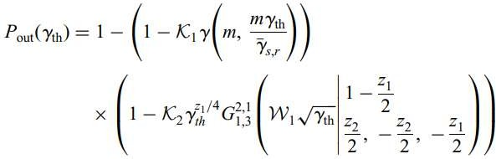

**Average bit error rate:** In this section, the BER of the DF based mixed FSO system is derived for various binary modulation techniques under no pointing errors.

**Table 1.** Parameters (*x* and *y*) for various binary modulation technique

|  |  |  |
| --- | --- | --- |
| Modulation Techniques | x | y |
| coherent binary frequency shift keying (CBFSK) | 0.5 | 0.5 |
| coherent binary phase shift keying (CBPSK) | 0.5 | 1 |
| non-coherent binary frequency shift keying (NBFSK) | 1 | 0.5 |
| differential binary phase shift keying (DBPSK) | 1 | 1 |

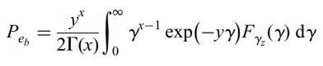**Binary modulation techniques:** the average BER for the considered cooperative system is expressed by,

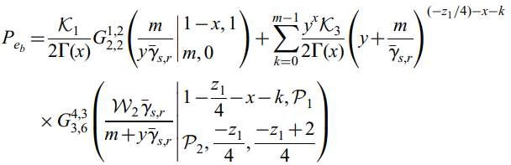where x and y are the BER parameters describing various binary modulation techniques, the mathematical expression for the BER for binary modulation techniques is given by,

**RESULTS**

In this section, the numerical results for the outage probability and the average BER are discussed for the considered DF based dual hop asymmetric FSO communication system. The FSO link experiences Gamma–Gamma turbulence, characterizing weak to strong turbulence along with path loss and pointing error.

We know that almost all the commercially available FSO systems operate in the wavelength range of 0.60 μm < l < 1.55 μm and that the attenuation inversely depends on the wavelength. Thus, in our paper, 1.55 μm wavelength is assumed because it undergoes least smoke and fog attenuation, making it favorable for varied atmospheric conditions. It is assumed that the average SNRs of both the links are equal.

Fig. 5 presents the outage performance of the considered system for various fading and turbulence parameters; no and significant (j = 1.8) pointing error; and γth is set to 10 dB. It is seen that stronger the effect of fading and turbulence, poorer is the outage performance of the system. Moreover, the degradation in the outage performance increases with the unified effect of turbulence and the pointing error. This can be explained by the fact that in case of significant pointing errors, the total impairment of the FSO link is the product of the impairments caused by the turbulence and the pointing errors. For example, at SNR = 40 dB, for a = 4, b = 4, j = 2.3, the outage probability is Pout = 6.308 × 10−4 which increases to Pout = 2.08 × 10−2 and 1.921 × 10−1 for a = 4.2, b = 1.4, j = 2.3 and a = 2, b = 0.5, j = 2.3, respectively.

An interesting observation is made here that the for moderate turbulence scenario, the effect of pointing error is quite significant. However, under severe turbulence case, the effect of pointing error is negligible as the system is already in highly degraded state.

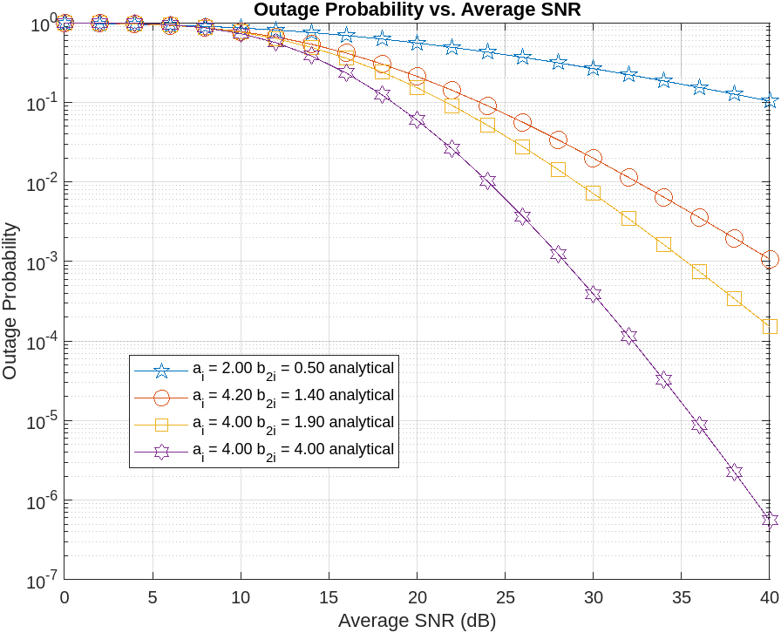 **Outage Probability vs. Average SNR:**

**Fig. 5** Outage probability against average SNR per hop for different values of fading and turbulence parameters, and *ξ* = 2.3

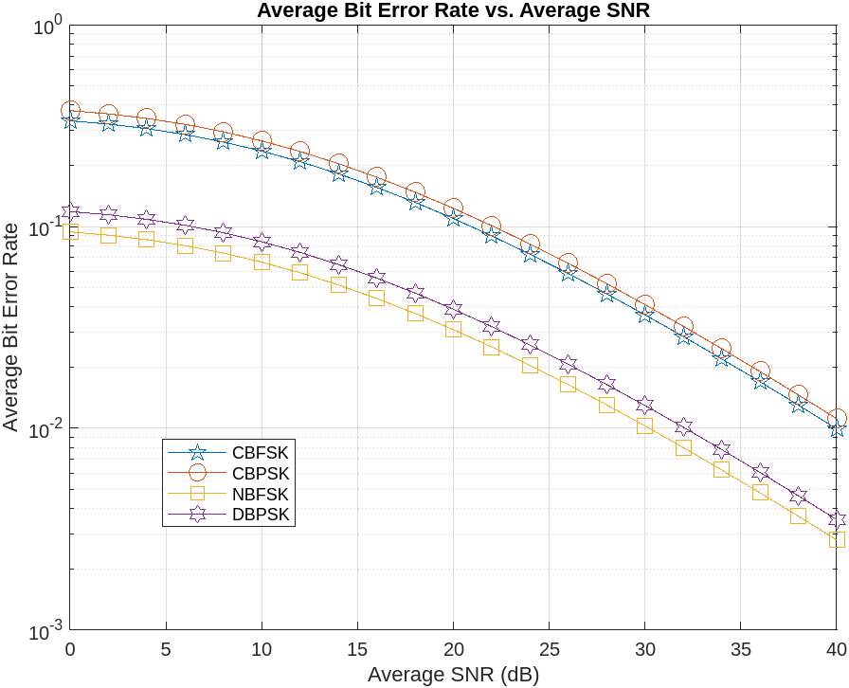**Average Bit Error Rate vs. Average SNR:**

**Fig. 6** Average BER against average SNR per hop for different modulation techniques, when a = 4.2, b = 1.4, *ξ* = 1.3

In Fig. 6, the average BER against the average SNR plots are analyzed for various modulation techniques, that is, CBPSK, CBFSK, NBFSK and DBPSK with fixed fading statistics and pointing error parameter, a = 4.2, b = 1.4 and *ξ* = 1.3. From Fig. 6, it can be observed that CBPSK outperforms the other modulation techniques because it is the most power-efficient modulation technique. Coherent techniques perform better than their corresponding non-coherent techniques because they have the knowledge of the phase of the carrier 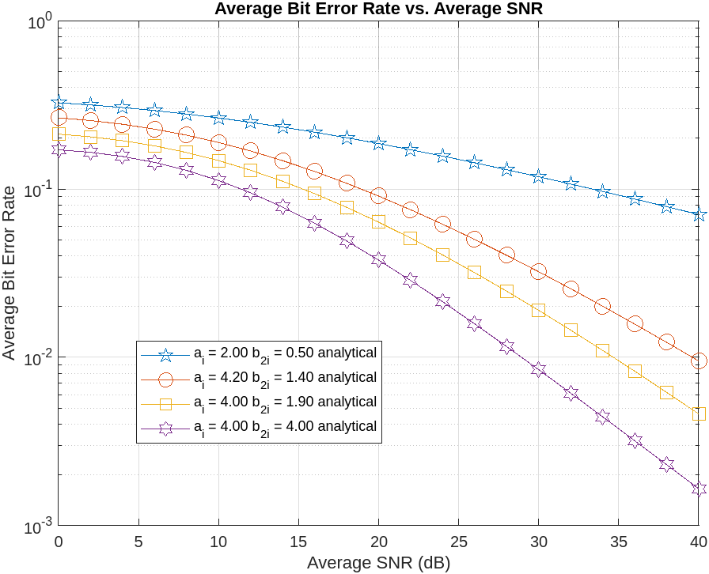at the receiver which can be exploited to recover the message signal correctly.

**Fig. 7** Average BER against average SNR per hop for different fading and turbulence conditions in case of CBFSK with *ξ* = 1.2

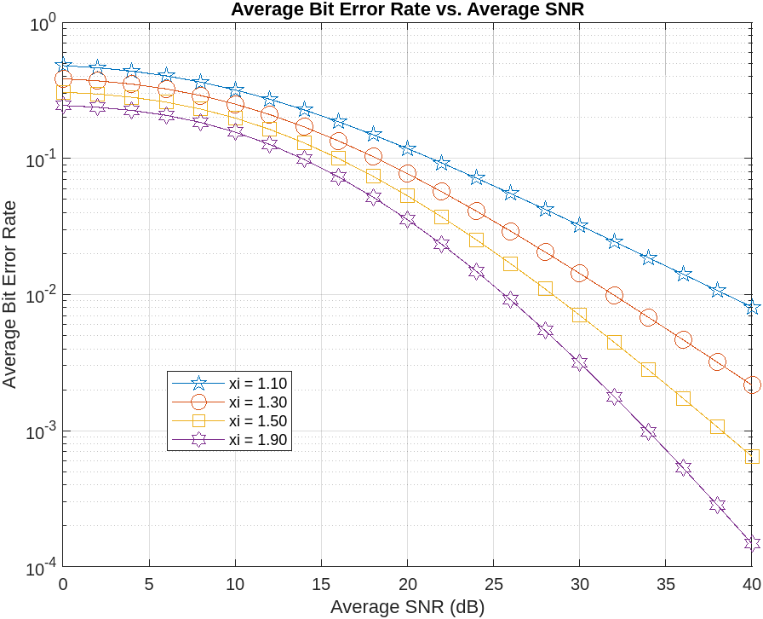**Fig. 8** Average BER against average SNR per hop for different values of pointing error parameter *ξ*, in case of CBPSK and a = 4 and b = 4

Fig. 7 presents the average BER performance of the asymmetric FSO system using CBFSK modulation technique, for different values of fading statistics but fixed pointing error parameter *ξ* = 1.2. It can be seen from the figure that severe the effect of fading and turbulence more is the degradation in the BER performance of the system. For example, at SNR = 40 dB and *ξ* = 1.2, a = 4, b = 1.9, the BER is Pe = 1.856 × 10−3 and it increases to Pe = 3.598 × 10−3 and Pe = 1.177 × 10−2, for a = 4.2, b = 1.4 and a = 2, b = 1, respectively. It can also be seen that the FSO link acts as the dominant link among both of them, as the BER under the strong fading and moderate turbulence is less than the BER under moderate fading and strong turbulence. Similar to Fig. 5. it is observed that the impact of pointing error increases as the severity in the turbulence decreases.

In Fig. 8, the average BER against average SNR plots are analyzed under CBPSK and for various values of pointing error parameter, that is, *ξ* = 1.1, 1.3, 1.5 and 1.9. The fading parameters are fixed to a = 4, b = 4. From the figure, it can be noted that stronger the effect of pointing errors, that is, smaller the value of pointing error parameter *ξ*, higher is the average BER. This behavior can be easily understood from the definition of j which explains that higher the pointing error displacement standard deviation at the destination, lower is the value of *ξ* and degraded is the average BER performance of the system. For example, at SNR = 40 dB, the BER, Pe = 1.84 × 10−6, 5.346 × 10−6, 4.113 × 10−5 and 1.079 × 10−3 for no pointing error scenario, *ξ* = 1.9, 1.5 and 1.1, respectively.

It can be observed from Figs. 5 and 7, that the simulation results for the outage probability and the average BER of the asymmetric FSO system match well with their corresponding analytical results. Moreover, it requires only 200 terms in case of turbulence only scenario and 250 terms in case of unified effect scenario, for the analytical results of the capacity of the considered system to match well with the simulated capacity.

**CONCLUSION**

In conclusion, this presents a comprehensive analysis of a dual-hop mixed FSO cooperative communication system assisted by High Altitude Platform Stations (HAPS). The study contributes to the understanding of system performance and optimization in two main aspects.

Firstly, mathematical expressions have been derived to characterize the statistical properties of the equivalent signal-to-noise ratio (SNR) in the considered DF-based dual-hop FSO system. These expressions enable the calculation of outage probability, Bit Error Rate (BER), and average capacity, considering the impact of fading, turbulence, and pointing errors on system performance. The analysis reveals that pointing error has a dominant effect under moderate turbulence, while the FSO link acts as the dominant link in the FSO system, particularly evident in BER plots.

Secondly, the study focuses on the role of HAPS in improving connectivity services in terrestrial networks. The proposed dual-hop hybrid FSO communication network, with HAPS operating in DF mode, is analyzed for OP and BER performance. Optimal power allocation schemes are investigated, considering factors such as fading parameters, turbulence conditions, HAPS position fluctuation, and transmitter beam width. Simulation results validate the accuracy of the analytical findings, indicating significant SNR improvement with the derived optimal power allocation scheme.

Overall, the study underscores the importance of HAPS-assisted communication systems in enhancing network coverage and performance. By integrating HAPS with terrestrial networks and leveraging hybrid FSO communication, the proposed approach offers insights into system design, optimization, and resilience against environmental challenges. These findings contribute to the advancement of optical-wireless communication systems, paving the way for future integrated aerial-terrestrial networks and improved connectivity services.

**CONFERENCE**

**PAPER**

**PROFF OF**

**SUBMISSION**

**REFERENCES**

1. Kedar, D., Aron, S.: ‘Urban optical wireless communication networks: The main challenges and possible solutions’, IEEE Commun. Mag., 2004, 42, (5), pp. S2—S7
2. Andrews, L., Phillips, R., Hopen, C.: ‘Laser beam scintillation with

applications’ (SPIE Press, New York, USA, 2001)

1. Bekkali, A., Naila, C.B., Kazaura, K., et al.: ‘Transmission analysis of OFDM-based wireless services over turbulent Radio-on-FSO links modeled by Gamma—Gamma distribution’, IEEE Photonics J., 2010, 2, (3), pp. 510—520
2. Moradi, H., Falahpour, M., Refai, H., et al.: ‘On the Capacity of hybrid FSO/RF links’. Proc. IEEE GLOBECOM, Miami, FL, December 2010, pp. 1—5
3. Tsiftsis, T.A., Sandalidis, H.G., Karagiannidis, G.K., et al.: ‘Optical wireless links with spatial diversity over strong atmospheric turbulence channels’, IEEE Trans. Wirel. Commun., 2009, 8, (2), pp. 951—957
4. Safari, M., Uysal, M.: ‘Relay-assisted free-space optical communication’, IEEE Trans. Wirel. Commun., 2008, 7, (12), pp. 5441—5449
5. Lee, E., Park, J., Han, D., et al.: ‘Performance analysis of the asymmetric dual-hop relay transmission with mixed RF/FSO links’, IEEE Photon. Technol. Lett., 2011, 23, (1), pp. 1642—1644
6. Bhatnagar, M.R.: ‘Performance analysis of decode-and-forward relaying in Gamma-Gamma fading channels’, IEEE Photon. Technol. Lett., 2012, 24, (7), pp. 545—547
7. Bhatnagar, M.R.: ‘Average BER analysis of differential modulation in DF cooperative communication system over Gamma-Gamma fading FSO links’, IEEE Commun. Lett., 2012, 16, (8), pp. 1228—1231
8. Anees, S., Bhatnagar, M.R.: ‘On the capacity of decode-and-forward dual-hop free space optical communication systems’. Proc. IEEE Wireless Communication and Network Conf. (WCNC), 6—9 April 2014, pp. 18—23
9. Anees, S., Bhatnagar, M.R.: ‘Performance of an amplify-and-forward dual-hop asymmetric RF-FSO communication system’, J. Opt. Commun. Netw., 2015, 7, (2), pp. 124—135
10. Nistazakis, H.E., Karagianni, E.A., Tsigopoulos, A.D., et al.: ‘Average capacity of optical wireless communication systems over atmospheric turbulence channels’, J. Lightw. Technol., 2009, 27, (8), pp. 974—979
11. PopooIa,W.O., Ghassemlooy, Z.: ‘BPSK subcarrier intensity modulated free-space optical communications in atmospheric turbulence’, IEEE/OSA J. Lightw. Technol., 2009, 27, (8), pp. 967—973
12. Samimi, H., Uysal, M.: ‘End-to-End performance of mixed RF/FSO transmission systems’, J. Opt. Commun. Netw., 2013, 5, (11), pp. 1139—1144
13. Peppas, K.P., Stassinakis, A.N., Nistazakis, H.E., et al.: ‘Capacity analysis of dual amplify-and-forward relayed free-space optical communication systems over turbulence channels with pointing errors’, IEEE J. Opt. Commun. Netw., 2013, 5, (9), pp. 1032—1042
14. Miridakis, N.I., Matthaiou, M., Karagiannidis, G.K.: ‘Multiuser relaying over mixed RF/FSO links’, IEEE Trans. Commun., 2014, 62, (5), pp. 1634—1645
15. Laneman, J.N., Tse, D.N.C., Wornell, G.W.: ‘Cooperative diversity in wireless networks: Efficient protocols and outage behavior’, IEEE Trans. Inf. Theory, 2004, 50, (11), pp. 3062—3080
16. Niu, M., Cheng, J., Holzman, J.F.: ‘Error rate performance comparison of coherent and subcarrier intensity modulated optical wireless communications’, J. Opt. Commun. Netw., 2013, 5, (6), pp. 554—564
17. Prudnikov, A.P., Brychkov, Y.A., Marichev, O.I.: ‘Integrals and Series’ (Gordon and Breach Science Publishers, New York, USA, 1990)
18. Tang, X., Wang, Z., Xu, Z., et al.: ‘Multihop free-space optical communications over turbulence channels with pointing errors using heterodyne detection’, J. Lightw. Technol., 2014, 32, (15), pp. 2597—2604
19. Papoulis, A., Pillai, S.U.: ‘Probability, Random variables and stochastic Processes’ (Tata Mcgraw-Hill, 2002, 4th edn.)
20. Luke, Y.L.: ‘The special functions and their approximation’ (Academic Press, New York, 1969, 1st edn.)